

**A Project Report on**

**A Survey on Predictive Healthcare Analytics Based on AI/ML**

**Submitted in partial fulfilment of the requirements for the award of the degree of**

**Bachelor of Technology in**

**Information Technology by**

**Udit Maurya**

**Roll No.: 2100970130117**

**Ritesh Kumar Roll No.: 2100970130093**

**Vishal Yadav**

**Roll No.: 2100970130127**

**Group no.: 24IT732**

**Under the Supervision of**

**Dr. Javed**

**Galgotias College of Engineering & Technology Greater Noida 201306**

**Uttar Pradesh, INDIA**

**Affiliated to**

**Dr. A.P.J. Abdul Kalam Technical University**

**Lucknow May**

**GALGOTIAS COLLEGE OF ENGINEERING & TECHNOLOGY GREATERNOIDA - 201306, UTTARPRADESH, INDIA.**

**DECLARATION**

We hereby that the project work presented in this project report entitled “**ASurvey on PredictiveHealthcareAnalytics BasedonAI/MLApproaches”**inpartialfulfillment of the requirement for the award of the degree of Bachelor of Technology in Information Technology, submitted to A.P.J Kalam Technical University, Lucknow is based on my work carried out at Department of Information Technology, Galgotias College of Engineering and Technology, Greater Noida. The work carried in the report is original and project work reported in this report has not been submitted by us for the award of any other degree or diploma.

Signature:

Name: Udit Maurya

Roll No: 2100970130117

Signature:

Name: Ritesh Kumar

Roll No: 2100970130093

Signature:

Name: Vishal Yadav

Roll No: 2100970130127

Date:

Place: Greater Noida

i

**GALGOTIAS COLLEGE OF ENGINEERING & TECHNOLOGY GREATERNOIDA - 201306, UTTARPRADESH, INDIA.**

**CERTIFICATE**

This is to certify that the project report entitled “**A SURVEY ON PREDUCTIVE**

**HEALTHCAREANALYTICS BASED ON AI/MLAPPROACHES”** submitted by **UDIT MAURYA (2000970130117), RITESH KUMAR (2100970130093), VISHAL YADAV (2100970130127)** to the Galgotias College of Engineering &Technology, UttarPradeshinPartialfulfillment fortheawardof Degree of Bachelor of Technology in Information Technology is a bonafide record of the project work carried out by them under my supervision during the year 2024 – 2025

**Dr. Javed**

**(Assistant Professor)**

**Deptt. of IT**

**Dr. Sanjeev Kumar Singh**

**(HOD IT)**

ii

**ACKNOWLEDGEMENT**

First of all, we would like to express our gratitude to our beloved **Chairman, Shri. Suneel Galgotia and CEO, Shri. Dhruv Galgotia** for providing necessary facilities tocarry out and finish the project successfully. We are grateful to our **Director, Dr. Mohd. Asim Qadri** for his support and encouragement.

Our special thank goes to **Dr. Sanjeev Kumar Singh, Head of the Department,**

**Information and Technology,** for providing an environment that encouraged us in working towards our goal and supported in completion of our project. This project gave us an opportunity to apply creative and critical thinking skills.

We would like to present our deep sense of gratitude to our project guide, **Dr. Javed,**

**Assistant Professor, Department of Information and Technology** who has always been a source of motivation and firm support for carrying out the project. The supervision and support that she gave truly helped in the progression of the project. Her cooperation is much indeed appreciated. We are highly obliged to his for his valuableadvicesandmoral supportduringresearchperiod.

Finally, our greatest and special gratitude goes to our family for their love and support.

Udit Maurya

(2100970130117)

Ritesh Kumar

(2100970130093)

Vishal Yadav

(2100970130127)

iii

**ABSTRACT**

The integration of Artificial Intelligence (AI) within predictive healthcare analytics heralds a promising era, poised to revolutionize patient care, clinical decision-making, and the allocation of healthcare resources. By meticulously analysing vast repositories of healthcare data,AI algorithms showcase an unparalleled ability to extract invaluable insights and predictions. This potential extends beyond merely improving patient outcomes to optimizing cost-effectiveness and refining interventions aimed at bolstering public health. Nonetheless, the successful incorporation of AI in healthcare analytics necessitates a vigilant approach to various challenges and ethical considerations. These encompass safeguarding patient privacy, ensuring fairness and equity in AI-driven healthcare decisions, and nurturing trust among stakeholders. To unlock the full potential of intelligence, it is important to address these ethical issues while maintaining ethical standards and social values. This research aims to conduct a comprehensive exploration of the multifaceted impact of AI integration in predictive healthcare analytics. Through an exhaustive examination of its implications, this study seeks not only to elucidate the transformative potential of AI in healthcare but also to contribute significantly to the collective understanding and future advancements of this pioneering technology within the healthcare sector.

**Keywords:** *Predictive Healthcare, Autonomic Computing, Artificial Intelligence, Machine Learning*

iv

**TABLE OF CONTENT**

**Chapter** **Page No.**

**Title Page**

**Declaration** **i**

**Certificate** **ii**

**Acknowledgement** **iii**

**Abstract** **iv**

**Table of Contents** **v**

**List of Figures** **vii**

**List of Tables** **viii**

**List of Abbreviation** **ix**

**Chapter 1 Introduction** **1-10**

1.1 Healthcare Predictive Analytics 1

1.2 History of Predictive Analytics 5

1.3 Importance of Predictive Analytics 6

1.4 Application of Predictive Analytics 7 1.5 Motivation 10

**Chapter 2 Literature Review** **11-13**

**Chapter 3 Designing and Methodology** **14-18**

3.1 Introduction to Designing 15

3.2 Reading the Data Set 16 3.3 Splitting Data for Training and Testing 17 3.4 Model Building 18

**Chapter 4 Implementation** **19-43**

v

**Chapter 5 Result Discussion** **44**

**Chapter 6 Conclusion** **45**

**Chapter 7 Future Scope** **46-50**

7.1 Incorporating AI Tools and System **46**

7.2 Setting up Infrastructure and Conclusion **46**

7.3 Integrating Autonomic Computing Technique **47**

7.4 Data Filtration Module **48**

7.5 Model Development and Configuration **48**

7.6 Model Monitoring and Update **49**

7.7 Continuous Improvement and Adaptation **50**

7.8 Quality Assurance and Optimization **50**

**References** **51-53**

vi

**List of Tables**

**Table** **Title**

4.1 Age – Sex with Diseases

4.2 Age – Sex with Diseases

4.3 Age – Diseases with certain counts

4.4 Age – Diseases without counts

4.5 Final Age – Disease Table

**Page No.**

19

20

22

22

24

vii

**List of Figure**

**Figure** **Title**

1.1 Predictive HealthcareAnalytics

3.1 Training of Machine Learning

3.2 Balanced Data Sheet

3.3 Proposed Methodology

4.1 Heatmap of Heart Disease

4.2 Distribution of Heart Disease

4.3 Types of Chest Pain

4.4 Distribution of RestingECG

4.5 Kernel Density Estimate

4.6 Various Distribution Graphs

4.7 Distribution ofAge

4.8 Distribution of RestingBP

4.9 Distribution of Cholestrol

4.10 Distribution of Oldpeak

4.11 Distribution of MaxHR

4.12 Robust Scaler

4.13 Disease-Count Graph

4.14 SVM Classifier

4.15 Naive Bayes Classifier

4.16 Random Forest Classifier

4.17 Confusion Matrix Map

**Page No.**

4

15

16

17

25

26

26

27

28

29

29

30

30

31

31

33

35

39

39

40

42

viii

**List of Abbreviations**

**AI** Artificial Intelligence

**ML** Machine Learning

**SVM** Support Vector Machine

**KDE** Kernel Density Estimate

**NBC** Naïve Bayes Classifier

**RFC** Random Forest Classifier

ix

**CHAPTER 1**

**INTRODUCTION**

**1.1 HEALTHCARE PREDICTIVE ANALYTICS**

Artificial Intelligence (AI) stands at the forefront of technological innovation, poised to

transform numerous sectors, particularly healthcare [1].

Predictive analytics is indeed a critical discipline in the realm of data analytics, particularly in healthcare, whereit holds immense potential to revolutionize patient care, operational efficiency, and disease management. Here's a breakdown of its significance across various healthcare domains:

Clinical Research: Predictive analytics enables researchers to analyse vast amounts of

healthcare data to identify patterns, correlations, and predictive factors related to diseases, treatments, and outcomes. This informs the design and execution of clinical trials, leading to more efficient research processes and accelerated discoveries. Development of New Treatments: By analysing patient data and clinical trial results, predictive analytics helps pharmaceutical companies and researchers identify potential targets for new treatments and therapies. This data-driven approach enhances the efficiency of drug development pipelines and facilitates the discovery of innovative therapies. Discovery of New Drugs:According to [22], predictive analytics in healthcare is vital for identifying patterns, correlations, and predictive factors related to diseases, treatments, and outcomes. It informs the design and execution of clinical trials, leading to more efficient research processes and accelerated discoveries. Prediction and Prevention of Diseases: Healthcare analytics enables early identification of individuals at risk of developing certain diseases or conditions based on their medical history, genetics, and lifestyle factors. This proactive approach allows healthcare providers to implement preventive interventions and personalized healthcare strategies to mitigate disease risk and improve patient outcomes.

Clinical Decision Support: Predictive analytics tools provide healthcare professionals

with real-time insights and decision support to aid in clinical decision-making. By analysing patient data and clinical guidelines, these systems help clinicians make

1

informed decisions about diagnosis, treatment plans, and patient management, leading to better outcomes and enhanced patient safety.

Quicker, More Accurate Diagnosis: Predictive analytics enhances diagnostic accuracy by analysing patient data and identifying subtle patterns or anomalies indicative of disease. This facilitates early detection and diagnosis of medical conditions, leading to timely interventions and improved patient outcomes. High Success Rates of Surgeries and Medications: Predictive analytics helps optimize surgical outcomes and medication efficacy by predicting patient responses and identifying factors that contribute to treatment success or failure. This personalized approach ensures that patients receive the most effective treatments tailored to their individual characteristics and needs.. Privacy, data security, ethical implications, and the indispensable requirement for human oversight in AI-driven decision-making processes are vital considerations. These factors necessitate a comprehensive evaluation of AI's impact on healthcare analytics, encompassing limitations, challenges, and ethical dimensions [7].

Automation of Hospital Administrative Processes: Healthcare analytics streamlines

administrative processes within hospitals and healthcare organizations by automating tasks such as scheduling, billing, and inventory management. This improves operational efficiency, reduces administrative burdens on staff, and enhances overall healthcare delivery.

In summary, predictive analytics has aprofound impact on various aspects of healthcare,

ranging from clinical research and treatment development to disease prevention, clinical decision support, and operational efficiency. By harnessing the power of data analytics, the healthcare industry can unlock valuable insights to improve patient outcomes, optimize resource allocation, and drive innovation in patient care.

Predictive analytics in healthcare offers numerous benefits that significantly improve

patient care and operational efficiency. Here are some key advantages:

1. Improved Patient Care: Predictive analytics leverages various data sources, including medical history, demographics, and comorbidities, to provide healthcare professionals with valuable insights. These insights guide decision-making, leading to better, data-driven care strategies tailored to each patient's needs.

2

2. Identification of At-Risk Patients: Predictive analytics can identify patients at higher risk of adverse health outcomes, allowing for early interventions to prevent complications. For example, it can predict the likelihood of hospitalization for patients with cardiovascular disease based on factors such as age, chronic illnesses, and medication adherence. Proactive care for at-risk patients reduces the burden on healthcare systems and improves patient outcomes.

3. Proactive Care Management: By predicting disease likelihood and identifying at-risk populations, healthcare organizations can implement proactive care management strategies. This may involve targeted interventions, and patient education programs aimed at preventing disease progression and reducing hospital readmissions.

4. Optimized Resource Allocation: Predictive analytics helps healthcare providers

allocate resources more efficiently by anticipating patient needs and demand for services. This includes optimizing staffing levels, bed utilization, and medical supply inventory to ensure timely and effective care delivery.

5. Enhanced Population Health Management: Predictive analytics enables healthcare organizations to monitor and manage the health of populations more effectively. By analyzing trends and patterns in health data, providers can identify population health risks, implement preventive measures, and allocate resources strategically to address community health needs.

6. Reduced Healthcare Costs: By identifying at-risk patients early and preventing costly complications, predictive analytics can help reduce healthcare costs. Proactive interventions, such as medication adherenceprograms and chronic disease management, can lead to fewer hospitalizations, emergency room visits, and other expensive healthcare services.

7. Improved Clinical Outcomes: Predictive analytics supports evidence-based decision-making, leading to improved clinical outcomes for patients. By identifying optimal treatment pathways, predicting treatment responses, and avoiding adverse events, healthcare professionals can achieve better patient outcomes and satisfaction.

Overall, predictive analytics in healthcare empowers providers with actionable insights that improve patient care, optimize resource utilization, and drive positive health outcomes across populations. By harnessing the power of data and technology,

3

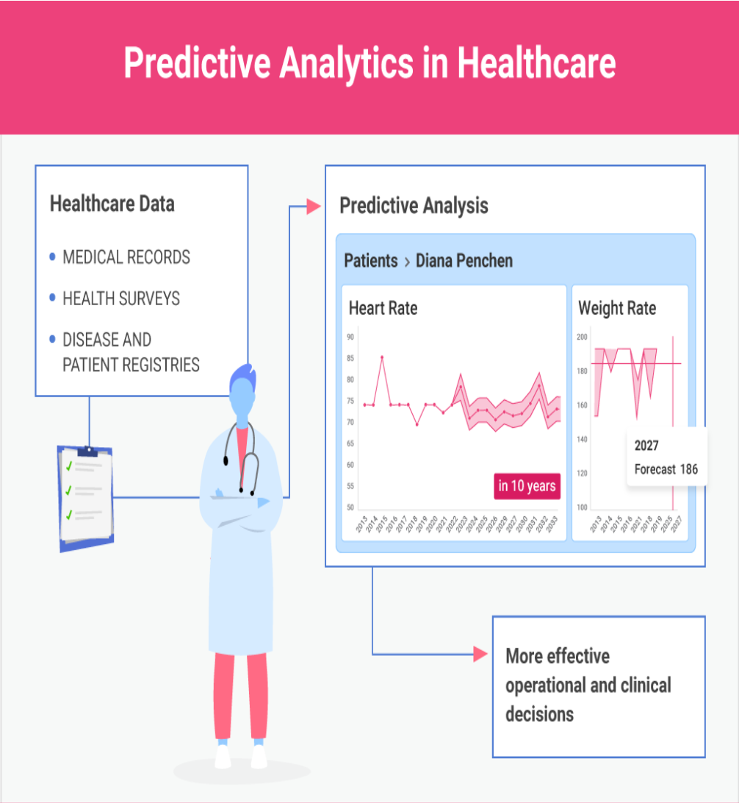

healthcare organizations can transform the way they deliver care and address the evolving needs of patients and communities.

Fig 1.1: Predictive Healthcare Analytics

4

**1.2 HISTORY OF PREDICTIVE ANALYTICS**

The origin of healthcare analytics can indeed be traced back to the mid-20th century,

particularly the 1950s, which saw the emergence of early attempts to apply computational methods to medical diagnosis and treatment. This period coincided with the advent of computers and the growing interest in leveraging them for various scientific and practical applications, including healthcare.

During the 1950s, medical records were predominantly paper-based, and computational analytics was limited by the available technology. However, there was a notable interest among researchers in developing automated applications to aid in medical diagnosis and treatment.

One significant milestone reflecting this interest is the publication of the article "Reasoning Foundations of Medical Diagnosis" in the journal Science in 1959. This article, authored by Robert S. Ledley and Lee B. Lusted, delved into the mathematical underpinnings of medical diagnosis. Whilethe terminology and symbols used may differ from modern biostatistics, the concepts presented laid the groundwork for future developments in healthcare analytics.

Ledley and Lusted's work explained how physicians make medical diagnoses using mathematical reasoning, providing insights into the processes involved in clinical decision-making. Although their approach may have been rudimentary by today's standards, it demonstrated an early recognition of the potential for computational methods to enhance medical practice.

Overall, the 1950s marked the beginning of efforts to apply computational and analytical techniques to healthcare, setting the stage for the subsequent evolution of healthcare analytics into the sophisticated field it is today.

In the 1970s, with the increasing accessibility of computers in academic research centers, therewas asurgeof interest in developing Medical Diagnostic Decision Support (MDDS) systems. These systems aimed to provide comprehensive diagnostic assistance by utilizing patient information input into computer programs. One of the most prominent systems from this era was INTERNIST-1, developed by researchers at the University of Pittsburgh.

The INTERNIST-1 system, described as an "experimental program for computer-assisted diagnosis in general internal medicine," was a result of over 15 person-years of work and extensive collaboration with physicians. Its knowledge base encompassed 500

5

diseases and 3,500 clinical manifestations across various medical specialties. Users could input positive and negative findings for a patient, and the system would generate a list of potential diagnoses, which would evolve as new information was added. Despite initial enthusiasm and capturing the attention of the medical community, INTERNIST-1 failed to gain widespread adoption. Its diagnostic recommendations were ultimately outperformed by those of leading physicians. Several factors contributed to its demise, along with the failure of MDDS systems in general:

1. PerformanceLimitations: WhileINTERNIST-1 showcased promising capabilities, its diagnostic accuracy fell short when compared to expert clinicians. This discrepancy undermined its utility and credibility among healthcare professionals.

2. Interface Design: INTERNIST-1 lacked an intuitive visual interface, as graphical user interfaces (GUIs) akin to modern systems were not yet prevalent. The absence of user-friendly interaction may have hindered its acceptance and usability among clinicians. 3. Technological Constraints: The absence of advanced machine learning techniques limited the system's ability to adapt and improve over time. Without modern data-driven algorithms, MDDS systems struggled to keep pace with the complexity of medical diagnosis and decision-making.

While INTERNIST-1 and similar MDDS systems represented pioneering efforts in applying computational methods to healthcare, their limitations underscored the challenges of integrating technology into clinical practice during the nascent stages of digital health innovation. Nonetheless, these early endeavors laid the groundwork for subsequent advancements in healthcare informatics and decision support systems.

**1.3 IMPORTANCE OF PREDICTIVE ANALYTICS**

1. Early Disease Detection: Predictive analytics can help identify individuals at risk of developing certain diseases or conditions based on various factors such as genetics, lifestyle, and medical history. Early detection allows fortimely interventions, potentially preventing the progression of diseases or minimizing their impact.

2. Personalized Medicine: By analyzing large datasets of patient information, predictive analytics can help healthcare providers tailor treatment plans to individual patients. This personalized approach ensures that patients receive the most effective treatments while minimizing adverse effects and unnecessary procedures.

3. Resource Optimization: Predictive analytics can forecast patient influxes, disease

6

outbreaks, and resource demands, enabling healthcare facilities to allocate staff, equipment, and other resources more efficiently. This leads to reduced wait times, improved patient satisfaction, and cost savings for healthcare organizations.

4. Risk Stratification: Healthcare providers can use predictive analytics to stratify patients based on their risk levels for various outcomes such as hospital readmission, complications, or mortality. This allows for targeted interventions and monitoring for high-risk patients, ultimately improving their outcomes and reducing healthcare costs associated with avoidable complications.

5. Chronic Disease Management: Predictive analytics can assist in managing chronic conditions by predicting exacerbations or complications before they occur. This proactive approach enables healthcare providers to intervene early, adjust treatment plans, and educate patients on self-management strategies, leading to better disease control and improved quality of life for patients.

6. Population Health Management: Predictive analytics can help public health officials and policymakers identify trends, hotspots, and high-risk populations for certain diseases or health issues. This information facilitates the development and implementation of targeted interventions, preventive measures, and public health campaigns to improve overall population health.

7. Research and Development: Predictive analytics can aid researchers in identifying patterns, correlations, and potential biomarkers associated with diseases, treatments, and outcomes. This information can accelerate the discovery of new treatments, drugs, and medical technologies, leading to advancements in healthcare and better patient care. Overall, predictive healthcare analytics empowers healthcare providers, policymakers, and researchers with valuable insights that can enhance patient care, optimize healthcare delivery, and drive innovation in the healthcare industry.

**1.4 APPLICATION OF PREDICTIVE ANALYTICS**

Predictive analytics encompasses a suite of statistical analytics approaches that blend techniques from data mining, predictive modeling, AI, and machine learning. Its aim is to leverage extensive datasets containing established facts within a particular domain or situation to estimate probabilities for various potential future scenarios. Predictive analytics functions as a probabilistic tool to enhance decision-making within intricate systems that produce a diverse array of apparently unpredictable results.

7

Predictive analytics finds utility across diverse sectors and disciplines, such as:

1. Marketing

2. Finance 3. Security 4. Insurance

5. Law Enforcement

6. Business Administration 7. Social Media

8. Healthcare

Despite the array of applications, predictive analytics follows a uniform procedure across various domains. Analysts leverage extensive datasets of historical events to assign probability scores to factors influencing the outcome of intricate events. This method typically involves a standardized three-step approach.

1. Logistic Regression2. Time Series Analytics3. Decision TreesHere are five promising healthcare application for predictive analytics:

1. Clinical Prediction:

Healthcare providers can utilize machine learning algorithms to analyze patient data and past medical outcomes, enabling them to forecast future trends in clinical settings. By leveraging analytics to identify probabilities, care providers can proactively anticipate the onset of various medical conditions.

During the Covid-19 pandemic, predictive analytics played a significant role in clinical assessments. One notable example is the US National COVID Cohort Collaborative, which applied machine learning models to patient data from 174,568 prior Covid hospitalizations. This approach aimed to map severity trajectories over time. By leveraging the study's findings to identify high-risk patients early, healthcare providers successfully reduced the mortality rate among patients under their care from 16.4% in March 2020 to 8.6% by September of the same year.

2. Assessing Patient Engagement and Behavior:

Time and resources lost dueto missed appointments and disregarded treatment regimens pose significant challenges for healthcare organizations, hindering their ability to allocate resources effectively. Implementing predictive analytics and leveraging behavioural science with patient data has demonstrated success in identifying individuals

8

at high risk for no-shows or non-adherence to treatment plans. Armed with these insights, administrators can proactively schedule interventions or increase the frequency of patient contact to improve overall engagement levels.

3. Early Intervention for Diseasing Progression and Comorbidities:

Physicians have long recognized the critical importance of early intervention in managing progressive diseases and conditions with comorbidities. However, effective early intervention has often relied on educated guesses rather than precise data analytics, particularly when dealing with large datasets that may contain outliers.

In recent times, healthcare institutions have embraced predictive analytical methods to sift through vast amounts of patient data, particularly in cases of progressive diseases. This approach has yielded promising outcomes, especially in risk assessment for cardiovascular diseases and complications related to diabetes. By enhancing treatment effectiveness for prevalent chronic conditions, healthcare organizations can create a ripple effect of long-term benefits. Fewer patients progress to critical stages of illness, allowing careproviders to allocate resources more efficiently to address other healthcare needs.

4. Resource Allocation and Acquisition:

Healthcare organizations operate within intricate systems managing extensive networks of resources. Even slight misallocations can have significant repercussions, particularly for national-scale organizations. By leveraging predictive analytics to discern seasonal or regional patterns in resource utilization, organizations can cultivate more adaptable resource management strategies, proactively addressing future demands. This proactive approach enables organizations to optimize their resource allocation, ultimately improving efficiency and effectiveness in healthcare delivery.

5. Hospital Overstays and Readmission:

Healthcare organizations face the challenge of managing critical yet limited resources, such as hospital beds, to deliver optimal care to the broader patient community. In traditional systems, hospital overstays often accumulate, leading to increased costs, longer patient wait times, and heightened risks of secondary infections.

Conversely, premature patient discharges may elevate the likelihood of readmission, compromising patient outcomes. Predictive analytics offers a solution by analyzing patient data, including age, medical history, and condition, to determine the average duration of hospitalization. Armed with this insight, organizations can adjust treatment plans and resource allocation more effectively, identifying outliers early through

9

established criteria. This proactive approach enables healthcare organizations to optimize the utilization of beds and rooms while minimizing the risks associated with both prolonged stays and premature discharges.

**1.5 MOTIVATION**

The motivation for conducting a survey on predictive healthcare analytics using AI/ML techniques stems from the urgent need to revolutionize healthcare delivery, improve patient outcomes, and optimize resource allocation. Predictive analytics, fueled by advancements in AI and ML, has the potential to transform the healthcare landscape by leveraging vast amounts of data to predict patient outcomes, identify high-risk individuals, and personalize treatment.

Furthermore, in the context of healthcare, predictive analytics holds immense promise for improving clinical decision-making, enhancing population health management, and reducing healthcare costs. By analyzing diverse data sources, including electronic health records (EHRs), medical imaging, genomic data, and real-time physiological measurements, predictive models can forecast disease onset, stratify patient risk, and optimize treatment protocols. This proactive approach to healthcare enables early intervention, preventive care, and targeted interventions, ultimately leading to better health outcomes and improved quality of life for patients.

A survey on predictive healthcare analytics using AI/ML lies in its potential to revolutionize healthcare delivery, improve patient outcomes, and address pressing healthcare challenges. By synthesizing existing methodologies, identifying key findings, and highlighting future directions, this survey aims to provide valuable insights for researchers, healthcare professionals, policymakers, and industry stakeholders.

10

**CHAPTER 2**

**LITERATURE REVIEW**

The field of predictive healthcare analytics, empowered by Artificial Intelligence (AI) and Machine Learning (ML) techniques, has witnessed exponential growth and garnered considerable attention in recent years. This literature review aims to provide a comprehensive overview of the current methodologies, applications, challenges, and future directions in predictive healthcare analytics using AI/ML.

Methodologically, supervised learning techniques such as logistic regression, decision trees, and neural networks have been extensively applied for predictive modeling in healthcare. These techniques enable the prediction of clinical outcomes, disease diagnosis, and treatment response by learning patterns from labeled data. Deep learning algorithms, including convolutional neural networks (CNNs) and recurrent neural networks (RNNs), have demonstrated remarkable success in medical imaging analytics, clinical natural language processing, and predictive modeling from electronic health records (EHRs). Moreover, unsupervised learning methods, such as clustering and anomaly detection, play a crucial role in uncovering hidden patterns and insights from unlabeled healthcare data, facilitating patient segmentation, population health management, and outlier detection.

In terms of applications, predictive healthcare analytics has been applied across various domains, including disease diagnosis and prognosis, personalized medicine, and healthcare resource allocation. Predictive models assist in the early detection and accurate diagnosis of diseases, estimate disease progression, and predict patient outcomes, thereby informing treatment decision-making and care planning.

Additionally, AI/ML-based predictive analytics enable the delivery of personalized

healthcare interventions tailored to individual patient characteristics and genetic profiles, improving treatment efficacy and patient outcomes. Furthermore, predictive analytics facilitates efficient resource allocation and healthcare resource management by forecasting patient demand, predicting healthcare utilization rates, and identifying

high-risk patient populations, thereby optimizing operational efficiency and reducing costs.

However, predictive healthcare analytics is not without challenges and considerations.

Data quality, interoperability, and privacy concerns pose significant challenges in

leveraging healthcare data for predictive modeling. Ethical and regulatory compliance, including patient privacy, data security, and algorithmic bias, must be carefully addressed to ensure the responsible and ethical use of healthcare data and AI/ML algorithms. Moreover, the black-box nature of some AI/ML models presents challenges in model interpretability and transparency, hindering clinician acceptance and patient trust.

11

Looking ahead, future directions and emerging trends in predictive healthcare analytics include the integration of multimodal data, the development of interoperable AI ecosystems, and advancements in explainable AI and model interpretability. By embracing these trends and fostering interdisciplinary collaboration, the healthcare industry can harness the power of AI/ML to improve patient outcomes, enhance operational efficiency, and advance population health management.

By conducting an exhaustive review of existing literature, meticulous data analytics, and scrutinizing real-world case studies, this study aims to offer meaningful insights into how artificial intelligence can reshape the landscape of healthcare analytics and drive transformative changes in healthcare delivery methods [5].

Several researchers have proposed frameworks and methodologies aimed at improving

healthcare systems and analytics:

1. Information Disclosure, Examination and Expectation in Medical services utilizing Information Mining and Analytics" by Akshay Raul et al.: This paper suggests a framework designed to create public awareness about alternative medications for specific drugs and their availability within a region. The proposed system assists patients in understanding substitute medications recommended by their doctors, utilizing information mining and analytics [10].

2. Medical care Information Investigation utilizing Dynamic Opening Assignment in Hadoop by Aditi Bansal and Priyanka Ghare: This work introduces a healthcare

framework utilizing Hadoop and the Dynamic Hadoop Opening Assignment (DHSA) technique. The focus lies on improving the performance of MapReduce jobs and maintaining the system efficiently [12].

3. Large Information Stream Figuring in Medical care Ongoing Examination by Van-Dai Ta, Chuan-Ming Liu, Generosity Wandile Nkabinde: This paper presents a

traditional architecture for large-scale healthcare analytics[11]. It leverages open-source tools such as Hadoop, Apache Tempest, Kafka, and NoSQL Cassandra [19].

.

12

4. Security Challenges in Healthcare Systems: For a comprehensive review on security challenges in healthcare systems by Razaque, A., Amsaad, F., Khan, M. J., Hariri, S., Chen, S., Chen, S., & Ji, X. (2019). Survey: Cybersecurity vulnerabilities, attacks, and solutions in the medical domain. IEEE Access, 7, 168774–168797. This paper provides insights into cybersecurity vulnerabilities, attacks, and solutions specific to the medical domain, contributing to the enhancement of healthcare systems and the development of robust security measures [3].

5. Huge information examination in medical services: commitment and Potential by Wullianallur Raghupathi and Viju Raghupathi: The authors discuss the potential of big data analytics in healthcare and provide insights beneficial for healthcare professionals and researchers. They advocate for a general architecture employing open-source tools like Hadoop, Apache Tempest, Kafka, and NoSQL Cassandra [13].

However, these works primarily concentrate on extracting features from specific healthcare data sources or focus solely on batch-oriented processing methods, resulting in higher latency. There is a need to consider continuous data influx, varied data formats, and substantial volume in the proposed architecture. Furthermore, research on autonomic computing, inspired by human capabilities, has garnered attention. Khalid et al. categorized different types of autonomic architectures [17].

Naturally Inspired Architecture: Modelled after human body functionality for self-

regulation.

Architecture for Large-Scale Distributed Systems: Developed by IBM and Microsoft

for large-scale system control.

Moreover, Kumar and Sharma proposed a vulnerability detection model employing autonomic computing to minimize software vulnerabilities [20].

Pena et al. demonstrated a model-driven approach for self-strategy-based systems during runtime processes [18].

13

**CHAPTER 3**

**DESIGNINGAND METHODOLOGY**

**3.1 INTRODUCTION TO DESIGNING:**

Gathering the Data: Data preparation is the primary step for any machine learning problem. We will be using a dataset from Kaggle for this problem. This dataset consists of two CSV files, one for training and one for testing. There are a total of 133 columns in the dataset, out of which 132 columns represent the symptoms, and the last column is the prognosis.

Cleaning the Data: Cleaning is the most important step in a machine learning project. The quality of our data determines the quality of our machine-learning model. So it is always necessary to clean the data before feeding it to the model for training. In our dataset, all the columns are numerical. The target column, i.e., prognosis, is of string type and is encoded to numerical form using a label encoder.

Model Building: After gathering and cleaning the data, it's ready to be used to train a machine learning model. We will be using this cleaned data to train the Support Vector Classifier, Naive Bayes Classifier, and Random Forest Classifier. We will use a confusion matrix to determine the quality of the models.

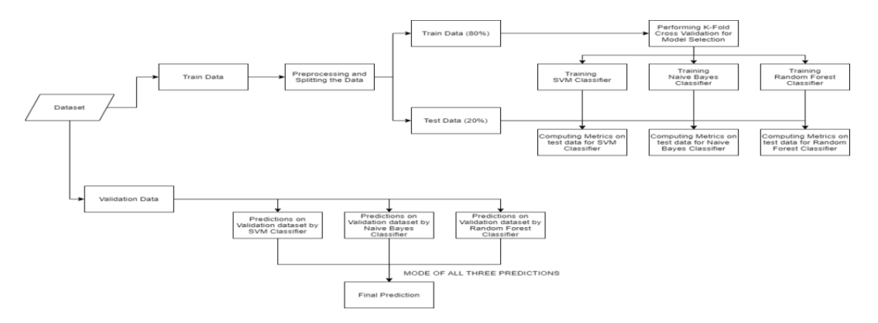Inference: After training the three models, we will predict the disease for the input symptoms by combining the predictions of all three models. This makes our overall prediction more robust and accurate.

Fig 3.1: Training of Machine Learning

15

Make sure that the Training and Testing are downloaded and the train.csv, test.csv are put in the dataset folder. Open jupyter notebook and run the code individually for better understanding.

**3.2 Reading the dataset**

Firstly we will be loading the dataset from the folders using the pandas library. While reading the dataset we will be dropping the null column. This dataset is a clean dataset with no null values and all the features consist of 0’s and 1s. Whenever we are solving a classification task it is necessary to check whether our target column is balanced or not. We will be using a bar plot, to check whether the dataset is balanced or not.

Fig 3.2: Balanced Data Sheet

From the above plot, we can observe that the dataset is a balanced dataset i.e. there are exactly 120 samples for each disease, and no further balancing is required. We can notice that our target column i.e. prognosis column is of object datatype, this format is

not suitable to train a machine learning model. So, we will be using a label encoder to

16

convert the prognosis column to the numerical datatype. Label Encoder converts the labels into numerical form by assigning a unique index to the labels. If the total number of labels is n, then the numbers assigned to each label will be between 0 to n-1.

**3.3 Splitting the data for training and testing the model**

Now that we have cleaned our data by removing the Null values and converting the labels to numerical format, It’s time to split the data to train and test the model. We will be splitting the data into 80:20 format i.e. 80% of the dataset will be used for training the model and 20% of the data will be used to evaluate the performance of the models.

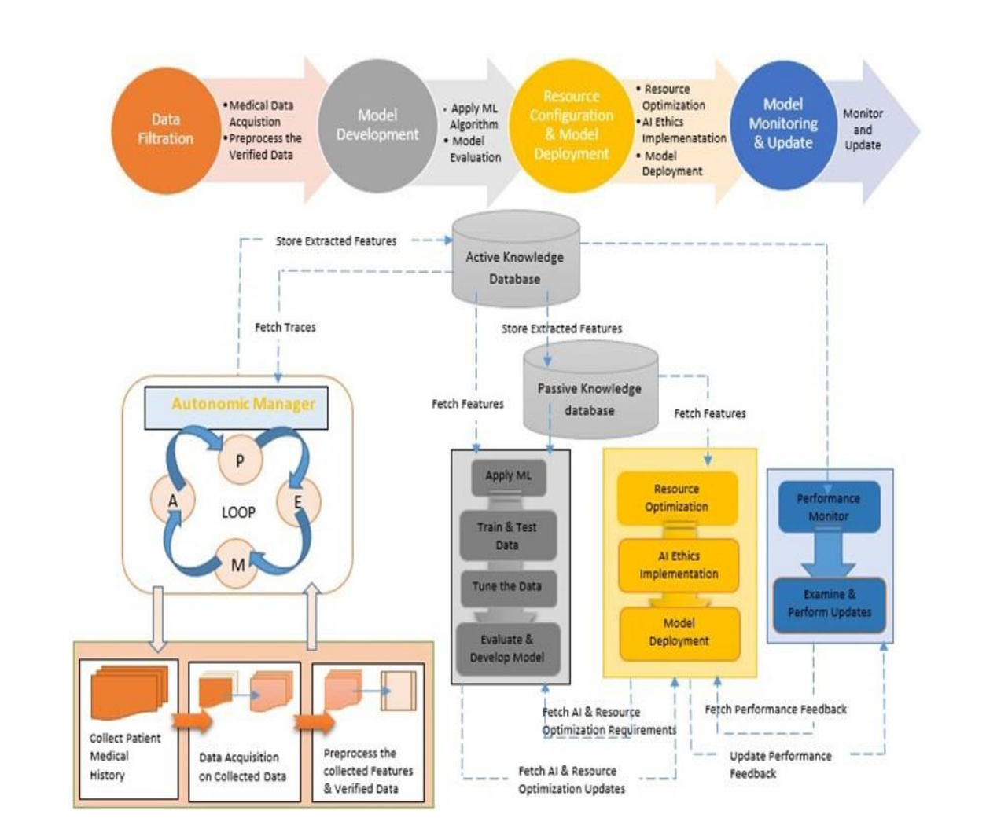

Fig 3.3: Proposed Methodology

17

**3.4 Model Building**

After splitting the data, we will be now working on the modeling part. We will be using K-Fold cross-validation to evaluate the machine-learning models. We will be using Support Vector Classifier, Gaussian Naive Bayes Classifier, and Random Forest Classifier for cross-validation. Before moving into the implementation part let us get familiar with k-fold cross-validation and the machine learning models.

1. K-Fold Cross-Validation**:** K-Fold cross-validation is one of the cross-validation techniques in which the whole dataset is split into k number of subsets, also known as folds, then training of the model is performed on the k-1 subsets and the remaining one subset is used to evaluate the model performance.

2. Support Vector Classifier: Support Vector Classifier is a discriminative classifier i.e. when given a labeled training data, the algorithm tries to find an optimal hyperplane that accurately separates the samples into different categories in hyperspace.

3. Gaussian Naive Bayes Classifier: It is aprobabilistic machine learning algorithm that internally uses Bayes Theorem to classify the data points.

4. Random Forest Classifier: Random Forest is an ensemble learning-based supervised machine learning classification algorithm. In a random forest classifier, all the internal decision trees are weak learners, and the outputs of these weak decision trees are combined i.e. mode of all the predictions is as the final prediction.

18

**CHAPTER 4**

**IMPLEMENTATION**

import os

import numpy as np import pandas as pd import warnings import seaborn as sns

import matplotlib.pyplot as plt import plotly.express as px warnings.filterwarnings("ignore")

pd.set_option("display.max_rows",None) %matplotlib inline

from sklearn import preprocessing import matplotlib matplotlib.style.use('ggplot')

from sklearn.preprocessing import LabelEncoder lab = LabelEncoder()

Read the CSV File or Data Collection

df =pd.read_csv("C:/Users/saifm/Downloads/heart.csv") df.head()

**Age Sex ChestPainType RestingBP Cholesterol FastingBS RestingECG MaxHR ExerciseAngina**

40 M ATA 140 289

49 F NAP 160 180

37 M ATA 130 283

48 F ASY 138 214

54 M NAP 150 195

0 Normal 172 N

0 Normal 156 N

0 ST 98 N

0 Normal 108 Y

0 Normal 122 N

Table 4.1: Age-Sex with Diseases

19

**Age Sex ChestPainType RestingBP Cholesterol FastingBS RestingECG MaxHR ExerciseAngina**

45 M TA 110 264

68 M ASY 144 193

57 M ASY 130 131

57 F ATA 130 236

38 M NAP 138 175

0 Normal 132 N

1 Normal 141 N

0 Normal 115 Y

0 LVH 174 N

0 Normal 173 N

Table 4.2: Age-Sex with Diseases

<class 'pandas.core.frame.DataFrame'> RangeIndex: 918 entries, 0 to 917 Data columns (total 12 columns):

# Column Non-Null Count Dtype

0 Age 918

1 Sex 918 2 ChestPainType 918 3 RestingBP 918 4 Cholesterol 918 5 FastingBS 918 6 RestingECG 918 7 MaxHR 918 8 ExerciseAngina 918 9 Oldpeak 918 10 ST_Slope 918

11 HeartDisease 918

non-null

non-null non-null non-null non-null non-null non-null non-null non-null non-null non-null

non-null

int64

object object int64 int64 int64 object int64 object float64 object

int64

dtypes: float64(1), int64(6), object(5) memory usage: 86.2+ KB

Data Cleansing

df.isna().sum() Age 0

20

Sex 0 ChestPainType 0 RestingBP 0 Cholesterol 0 FastingBS 0 RestingECG 0 MaxHR 0 ExerciseAngina 0 Oldpeak 0 ST_Slope 0 HeartDisease 0 dtype: int64

df1 = df.select_dtypes(exclude=object)

df2 = df.select_dtypes(include=object) df3 = df1.drop('HeartDisease',axis=1) RestingBP

Cholesterol FastingBS MaxHR int64

int64 int64 int64 Oldpeak

HeartDisease dtype: object float64 int64

df2.dtypes()

Sex object

ChestPainType object RestingECG object ExerciseAngina object ST_Slope object dtype: object

21

df1.describe() #this function gives the summary of the statistics

**Age RestingBP Cholesterol** **FastingBS** **MaxHR** **Oldpeak HeartDisease**

**count** 918.000000 918.000000 918.000000 918.000000 918.000000 918.000000 918.000000

**mean** 53.510893

**std** 9.432617

**min** 28.000000

**25%** 47.000000

**50%** 54.000000

**75%** 60.000000

**max** 77.000000

132.396514

18.514154

0.000000

120.000000

130.000000

140.000000

200.000000

198.799564

109.384145

0.000000

173.250000

223.000000

267.000000

603.000000

0.233115

0.423046

0.000000

0.000000

0.000000

0.000000

1.000000

136.809368

25.460334

60.000000

120.000000

138.000000

156.000000

202.000000

0.887364

1.066570

-2.600000

0.000000

0.600000

1.500000

6.200000

0.553377

0.497414

0.000000

0.000000

1.000000

1.000000

1.000000

Table 4.3: Age – Diseases with certain counts

Processing Data

for i in range(0,df2.shape[1]):

df2.iloc[:,i] = lab.fit_transform(df2.iloc[:,i]) df2.head()

**Sex** **ChestPainType** **RestingECG** **ExerciseAngina** **ST_Slope**

**0** 1 1 1 0 2

**1** 0 2 1 0 1

**2** 1 1 2 0 2

**3** 0 0 1 1 1

**4** 1 2 1 0 2

Table 4.4: Age – Diseases without counts

22

df,ispa().sum()

Age 0 ResingBP 0 Cholestrol 0 FastingBS 0 Oldspeaks 0 Sex 0 ChestPainType 0 RestingECG 0 ST Slope 0

dtype: int64

string_col=data.select_dtypes(include="object").columnsdata[string_col]=data[string _col].

astype("string") data.dtypes

Age

Sex ChestPainType Cholestrol RestingECG MaxHR

ST Slope Heart Disease

dtypes:

int64

string[python] string[python] int64 string[python] int64 string[python] int64

object

Getting the categorical columns

string_col = data.select_dtypes("string").columns.to_list() num_col = data.columns.to_list()

print(num_col)

for col in string_col:

23

num_col.remove(col) num_col.remove("HeartDisease") data.describe().T

heart_df = pd.read_csv('Datasets/heart.csv') st.title('Heart Checkup') st.sidebar.header('Patient Data') st.subheader('Training Data Stats') st.write(heart_df.describe())

x = heart_df.drop(['target'], axis=1)

y = heart_df['target']

x_train, x_test, y_train, y_test = train_test_split(x, y, test_size=0.2, random_state=0)

**Age RestingBP Cholesterol FastingBS MaxHR Oldpeak HeartDisease Sex RestingECG**

**0** 40.0 140.0 289.0

**1** 49.0 160.0 180.0

**2** 37.0 130.0 283.0

**3** 48.0 138.0 214.0

**4** 54.0 150.0 195.0

0.0 172.0 0.0 0.0 1 1

0.0 156.0 1.0 1.0 0 1

0.0 98.0 0.0 0.0 1 2

0.0 108.0 1.5 1.0 0 1

0.0 122.0 0.0 0.0 1 1

Table 4.5: Final Age – Diseases Table

Exploratory Data Analytics Correlation Matrix

px.imshow(df.corr(),title="Correlation Plot of the Heart Failure Prediction") heart_df = pd.read_csv('Datasets/heart.csv')

st.title('Heart Checkup') st.sidebar.header('Patient Data')

24

st.subheader('Training Data Stats') st.write(heart_df.describe()) st.title('Heart Checkup') st.sidebar.header('Patient Data') st.subheader('Training Data Stats') st.write(heart_df.describe())

print(predictDisease("Itching,Skin Rash,Nodal Skin Eruptions")) {'rf_model_prediction': 'Fungal infection', 'naive_bayes_prediction': 'Fungal infe ction', 'svm_model_prediction': 'Fungal infection', 'final_prediction': 'Fungal in fection'}

x = heart_df.drop(['target'], axis=1) y = heart_df['target']

x_train, x_test, y_train, y_test = train_test_split(x, y, test_size=0.2, random_state=0

sns.heatmap(df.corr(),annot=True,linewidths=0.5)

plt.show()

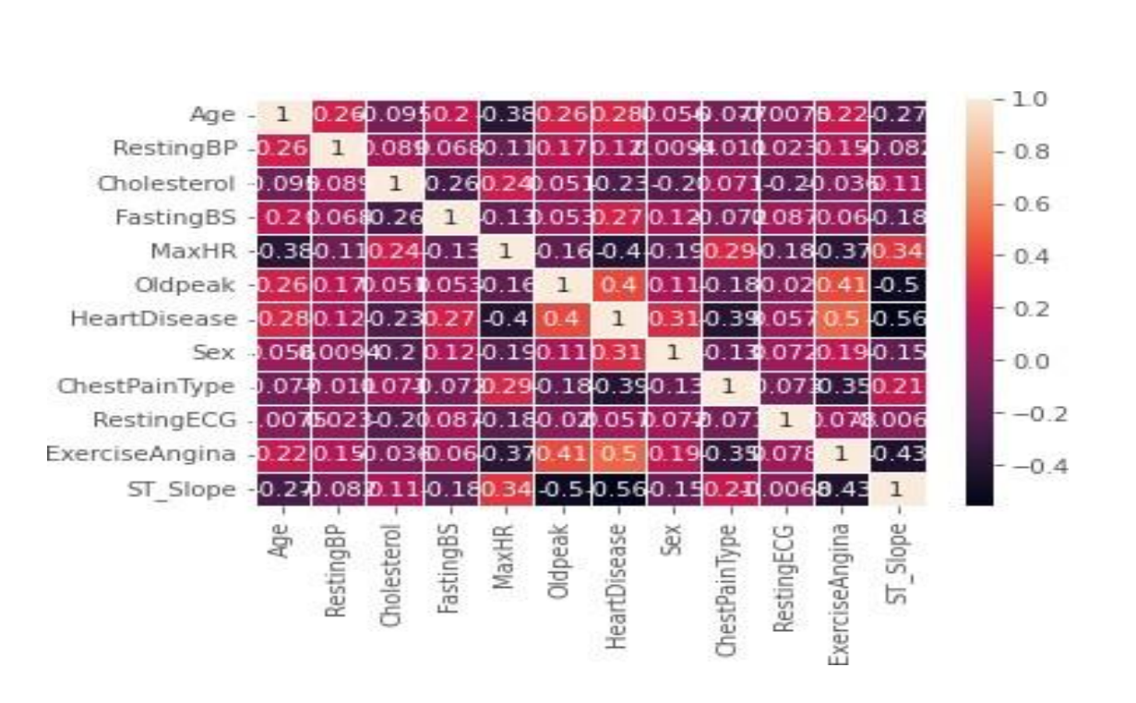

Fig 4.1: Heatmap for Heart Disease

25

df['HeartDisease'].value_counts()

# Shows the Distribution of Heart Diseases with respect to male and female

fig = px.histogram(data, x="HeartDisease", color="Sex",hover_data=data.columns, title="Distribution of Heart Diseases", barmode="group")

fig.show()

Fig 4.2: Distribution of Heart Disease

fig=px.histogram(data, x="ChestPainType", color="Sex",hover_data=data.columns, title="Types of Chest Pain [1:Male,0:Female]")

fig.update_layout(bargap=0.2) fig.show()

Fig 4.3: Types of Chest Pain [1-Male, 0-Female]

26

fig=px.histogram(data, x="Sex",hover_data=data.columns, title="Sex Ratio in the Data")

fig.show()

Fig 4.4: Distribution of RestingECG

plt.figure(figsize=(15,10))

sns.pairplot(df,hue="HeartDisease")

plt.title("Looking for Insites in Data") plt.legend("HeartDisease") plt.tight_layout()

plt.plot()

27

Fig 4.5: Kernel Density estimate KDE

plt.figure(figsize=(15,10))

for i,col in enumerate(data.columns,1): plt.subplot(4,3,i) plt.title(f"Distribution of {col} Data") sns.histplot(df[col],kde=True) plt.tight_layout() plt.plot()

plt.figure(figsize=(10,15))

for i,col in enumerate(data.columns,4.3,i): plt.subplot(1) plt.title(f"Distribution of {col} Data") sns.histplot(df[col],kde=True) plt.tight_layout() plt.plot()

28

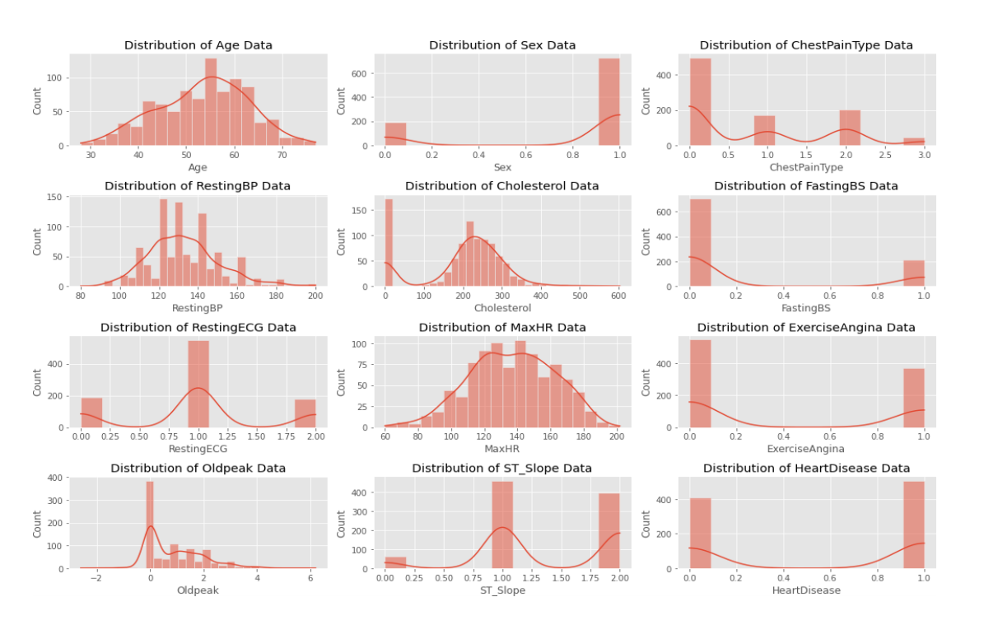

Fig 4.6: Various Distribution Graph

Outliers

fig = px.box(data,y="Age",x="HeartDisease",title=f"Distribution of Age") fig.show()

Fig 4.7: Distribution of Age

29

Fig=px.box(df,y="RestingBP",x="HeartDisease",title=f"DistributionofRestingBP" ,color="Sex")

fig.show()

Fig 4.8: Distribution of RestingBP

fig = px.box(df,y="Cholesterol",x="HeartDisease",title=f"Distribution of Cholestrol")

fig.show()

Fig 4.9: Distribution of Cholestrol

30

fig=px.box(df,y="Oldpeak",x="HeartDisease",title=f"Distribution of Oldpeak") fig.show()

Fig 4.10: Distribution of OldPeak

fig=px.box(df,y="MaxHR",x="HeartDisease",title=f"Distribution of MaxHR")

fig.show()

Fig 4.11: Distribution of MaxHR

31

x = pd.DataFrame({ #Distribution with lower outliers

'x1':np.concatenate([np.random.normal(20,2,1000),np.random.normal(1,2,25)]), #Distribution with higher outliers 'x2':np.concatenate([np.random.normal(30,2,1000),np.random.normal(50,2,25)]), })

np.random.normal

scaler = preprocessing.RobustScaler() robust_df = scaler.fit_transform(x) robust_df = pd.DataFrame(robust_df,columns=['x1','x2'])

scaler = preprocessing.StandardScaler() standard_df = scaler.fit_transform(x)

standard_df = pd.DataFrame(standard_df,columns=['x1','x2'])

scaler = preprocessing.MinMaxScaler() minmax_df = scaler.fit_transform(x) minmax_df = pd.DataFrame(minmax_df,columns=['x1','x2'])

fig, (ax1,ax2,ax3,ax4) = plt.subplots(ncols=4,figsize=(20,5)) ax1.set_title('Before

Scaling')

sns.kdeplot(x['x1'],ax=ax1,color='r'),sns.kdeplot(x['x2'],ax=ax1,color='b') ax2.set_title('After Robust Scaling')

sns.kdeplot(robust_df['x1'],ax=ax2,color='red')

sns.kdeplot(robust_df['x2'],ax=ax2,color='blue') ax3.set_title('After Standard Scaling')

sns.kdeplot(standard_df['x1'],ax=ax3,color='black') sns.kdeplot(standard_df['x2'],ax=ax3,color='g') ax4.set_title('After Min-Max Scaling')

sns.kdeplot(minmax_df['x1'],ax=ax4,color='black') sns.kdeplot(minmax_df['x2'],ax=ax4,color='g')

32

plt.show()

Fig 4.12: Robust Scaler

#Applying and Checking Accuracy and Precision of different Classification Models

from sklearn.naive_bayes import GaussianNB

from sklearn.model_selection import GridSearchCV from sklearn.linear_model import LogisticRegression from sklearn.metrics import accuracy_score

from sklearn.metrics import roc_curve from sklearn.metrics import roc_auc_score

from sklearn.metrics import confusion_matrix

from sklearn.model_selection import cross_val_score from sklearn.model_selection import train_test_split from sklearn.preprocessing import StandardScaler

from sklearn.ensemble import RandomForestClassifier import xgboost as xgb

from sklearn.svm import SVC

from sklearn.neighbors import KNeighborsClassifier

33

from sklearn.ensemble import AdaBoostClassifier from sklearn.metrics import precision_score

models = {

'Logistic_Regression':LogisticRegression(), 'Random_Forest':RandomForestClassifier(), 'XGBoost':xgb.XGBClassifier(), 'SVM':SVC(kernel = 'rbf'), 'KNN':KNeighborsClassifier(n_neighbors = 10), 'Naive_Bayes':GaussianNB()

}

for i in models:

obj = models[i] obj.fit(train_X,train_Y) obj_pred = obj.predict(test_X)

accuracy = accuracy_score(test_Y,obj_pred)

precision = precision_score(test_Y,obj_pred,zero_division=1) print('Accuracy of '+i+': ',accuracy)

print('Precision of '+i+': ',precision)

# Reading the train.csv by removing the last column # since it's an empty column

DATA_Path = "C:/Users/saifm/Downloads/Training data.csv" data = pd.read_csv(DATA_Path).dropna(axis=1)

# Checking whether the dataset is balanced or not disease_counts = data["prognosis"].value_counts() temp_df = pd.DataFrame({

"Disease": disease_counts.index, "Counts": disease_counts.values

})

plt.figure(figsize = (18,8))

sns.barplot(x = "Disease", y = "Counts", data = temp_df) plt.xticks(rotation=90)

34

plt.show()

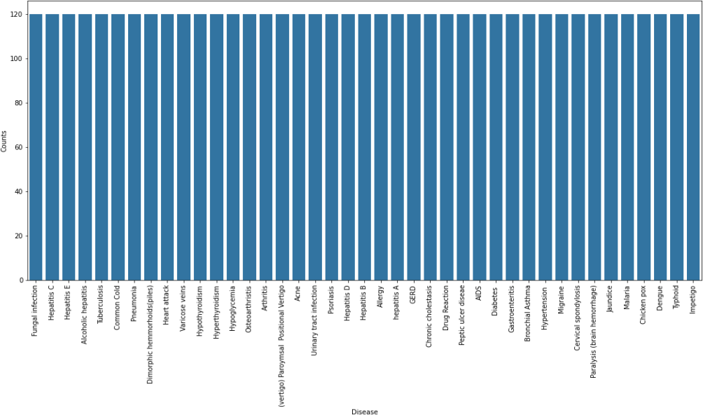

Fig 4.13: Disease – Counts Graph

# Encoding the target value into numerical value using LabelEncoder

encoder = LabelEncoder().data["prognosis"] = encoder.fit_transform(data["prognosis"])

**Splitting the data for training and testingthe model** X = data.iloc[:,:-1]

y = data.iloc[:, -1]

X_train, X_test, y_train, y_test =train_test_split( X, y, test_size = 0.2, random_state = 24)

print(f"Train: {X_train.shape}, {y_train.shape}") print(f"Test: {X_test.shape}, {y_test.shape}")

**Model Building using K-Fold Cross-Validation for model selection**

# Defining scoring metric for k-fold cross validation

35

def cv_scoring(estimator, X_train, y_train):

return accuracy_score(y_train, estimator.predict(X_train)) # Initializing Models

models = { "SVC":SVC(),

"Gaussian NB":GaussianNB(),

"Random Forest":RandomForestClassifier(random_state=18) }

# Producing cross validation score for the models for model_name in models:

model = models[model_name]

scores = cross_val_score(model, X_train, y_train, cv = 10, n_jobs = -1,

scoring = cv_scoring) print("=="*30) print(model_name) print(f"Scores: {scores}")

print(f"Mean Score: {np.mean(scores)}") ============================================================ SVC

Scores: [1. 1. 1. 1. 1. 1. 1. 1. 1. 1.] Mean Score: 1.0

============================================================ Gaussian NB

Scores: [1. 1. 1. 1. 1. 1. 1. 1. 1. 1.] Mean Score: 1.0

============================================================ Random Forest

Scores: [1. 1. 1. 1. 1. 1. 1. 1. 1. 1.] Mean Score: 1.0

**Building robust classifier by combination of all models**

36

# Training and testing SVM Classifier svm_model = SVC() svm_model.fit(X_train, y_train)

preds = svm_model.predict(X_test)

print(f"Accuracy on train data by SVM Classifier\

: {accuracy_score(y_train, svm_model.predict(X_train))*100}")

print(f"Accuracy on test data by SVM Classifier\ : {accuracy_score(y_test, preds)*100}")

cf_matrix = confusion_matrix(y_test, preds) plt.figure(figsize=(12,8)) sns.heatmap(cf_matrix, annot=True)

plt.title("Confusion Matrix for SVM Classifier on Test Data") plt.show()

# Training and testing Naive Bayes Classifier nb_model = GaussianNB() nb_model.fit(X_train, y_train)

preds = nb_model.predict(X_test)

print(f"Accuracy on train data by Naive Bayes Classifier\

: {accuracy_score(y_train, nb_model.predict(X_train))*100}")

print(f"Accuracy on test data by Naive Bayes Classifier

: {accuracy_score(y_test, preds)*100}")

cf_matrix = confusion_matrix(y_test, preds) plt.figure(figsize=(12,8)) sns.heatmap(cf_matrix, annot=True)

plt.title("Confusion Matrix for Naive Bayes Classifier on Test Data") plt.show()

models = { "SVC":SVC(),

"Gaussian NB":GaussianNB(),

"Random Forest":RandomForestClassifier(random_state=18)

37

# Training and testing Random Forest Classifier

rf_model = RandomForestClassifier(random_state=18) rf_model.fit(X_train, y_train) preds = rf_model.predict(X_test)

print(f"Accuracy on train data by Random Forest Classifier\

: {accuracy_score(y_train, rf_model.predict(X_train))*100}")

print(f"Accuracy on test data by Random Forest Classifier\ : {accuracy_score(y_test, preds)*100}")

def cv_scoring(estimator, X_train, y_train):

return accuracy_score(y_train, estimator.predict(X_train)) # Initializing Models

models = { "SVC":SVC(),

"Gaussian NB":GaussianNB(),

"Random Forest":RandomForestClassifier(random_state=18) }

rf_model = RandomForestClassifier(random_state=18) rf_model.fit(X_train, y_train) preds = rf_model.predict(X_test)

print(f"Accuracy on train data by Random Forest Classifier\

: {accuracy_score(y_train, rf_model.predict(X_train))*100}")

cf_matrix = confusion_matrix(y_test, preds) plt.figure(figsize=(12,8))

sns.heatmap(cf_matrix, annot=True)

plt.title("Confusion Matrix for Random Forest Classifier on Test Data") plt.show()

**Output-**

Accuracy on train data by SVM Classifier: 100.0 Accuracy on test data by SVM Classifier: 100.0

38

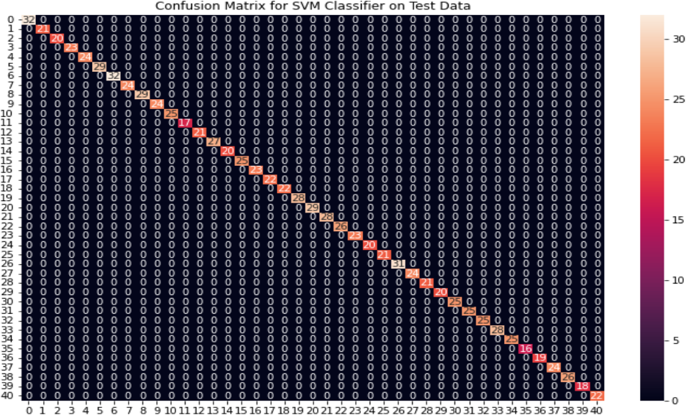

Fig 4.14: SVM Classifier

**Output-**

Accuracy on train data by Naïve Bayes Classifier: 100.0 Accuracy on test data by Naïve Bayes Classifier: 100.0

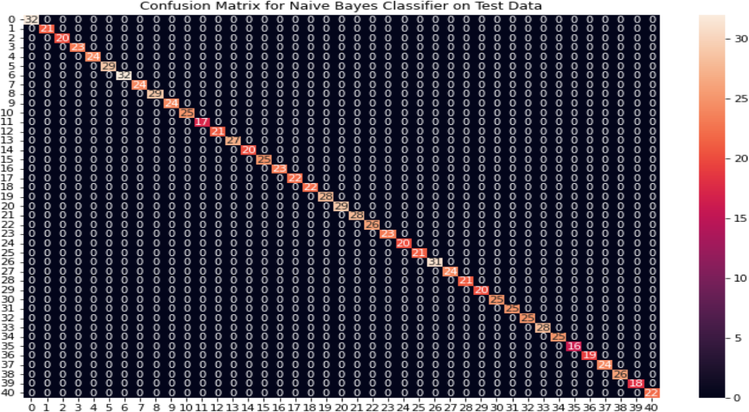

Fig 4.15: NB Classifier

39

**Output-**

Accuracy on train data by Random Forest Classifier: 100.0 Accuracy on test data by Random Forest Classifier: 100.0

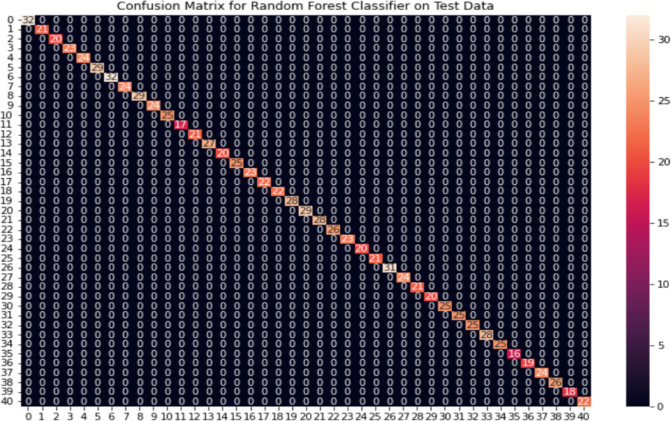

Fig 4.16: RF Classifier

**Fitting the model on whole data and validation on the test dataset** # Training the models on whole data

final_svm_model = SVC() final_nb_model = GaussianNB()

final_rf_model = RandomForestClassifier(random_state=18) final_svm_model.fit(X_train, y_train) final_nb_model.fit(X_train, y_train) final_rf_model.fit(X_train, y_train)

# Reading the test data

40

test_data = pd.read_csv("C:/Users/saifm/Downloads/Testing data.csv").dropna(axis=1)

test_X = test_data.iloc[:, :-1]

test_Y = encoder.transform(test_data.iloc[:, -1])

# Making prediction by take mode of predictions # made by all the classifiers svm_preds = final_svm_model.predict(test_X) nb_preds = final_nb_model.predict(test_X) rf_preds = final_rf_model.predict(test_X)

final_preds = [mode([i,j,k])[0][0] for i,j, k in zip(svm_preds, nb_preds, rf_preds)]

print(f"Accuracy on Test dataset by the combined model\

: {accuracy_score(test_Y, final_preds)*100}")

cf_matrix = confusion_matrix(test_Y, final_preds) plt.figure(figsize=(12,8))

sns.heatmap(cf_matrix, annot = True)

plt.title("Confusion Matrix for Combined Model on Test Dataset") plt.show()

# creating input data for the models

input_data = [0] * len(data_dict["symptom_index"]) for symptom in symptoms:

index = data_dict["symptom_index"][symptom] input_data[index] = 1

# reshaping the input data and converting it # into suitable format for model predictions input_data = np.array(input_data).reshape(1,-1)

41

**Output-**

Accuracy on train data by Combined Model Data Accuracy on test data by Combined Model Data

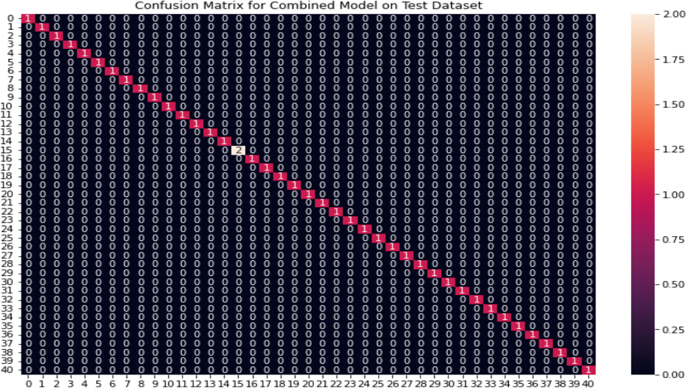

Fig 4.17: Confusion matrix heatmap

**Creating a function that can symptoms as inputs and generate prediction**

warnings.filterwarnings("ignore", category=UserWarning) symptoms = X_train.columns.values

# Creating a symptom index dictionary to encode the # input symptoms into

numerical form symptom_index = {}

for index, value in enumerate(symptoms):

symptom_index = ” ”.join([i.capitalize() for i in value.split(“_”)])

symptom_index[symptom] = index

data_dict = {

"symptom_index":symptom_index,

42

"predictions_classes":encoder.classes_ }

# Defining the Function

# Input: string containing symptoms separated by commas # Output: Generated predictions by models

def predictDisease(symptoms): symptoms = symptoms.split(",")

# creating input data for the models

input_data = [0] * len(data_dict["symptom_index"]) for symptom in symptoms:

index = data_dict["symptom_index"][symptom] input_data[index] = 1

# reshaping the input data and converting it # into suitable format for model predictions input_data = np.array(input_data).reshape(1,-1)

# generating individual outputs

rf_prediction = data_dict["predictions_classes"][final_rf_model.predict(input_dnb_prediction =data_dict["predictions_classes"][final_nb_model.predict(input_d_svm_prediction =data_dict["predictions_classes"][final_svm_model.predict(input)

# making final prediction by taking mode of all predictions

final_prediction = mode([rf_prediction, nb_prediction, svm_prediction])[0][0] predictions = {

"rf_model_prediction": rf_prediction,

"naive_bayes_prediction": nb_prediction, "svm_model_prediction": svm_prediction, "final_prediction":final_prediction

}

return predictions

# Testing the function

print(predictDisease("Itching,Skin Rash,Nodal Skin Eruptions"))

43

**CHAPTER 5**

**RESULT DISCUSSION**

Accuracy of Logistic_Regression: 0.8532608695652174

Precision of Logistic_Regression: 0.831858407079646

Accuracy of Random_Forest: 0.8804347826086957

Precision of Random_Forest: 0.8571428571428571

Accuracy of XGBoost: 0.8641304347826086

Precision of XGBoost: 0.8407079646017699

Accuracy of SVM: 0.8695652173913043

Precision of SVM: 0.8545454545454545

Accuracy of KNN: 0.8586956521739131

Precision of KNN: 0.8958333333333334

Accuracy of Naive_Bayes: 0.8804347826086957

Precision of Naive_Bayes: 0.8636363636363636

**Logistic Regression is best suit for this model**

44

**CHAPTER 6**

**CONCLUSION**

The envisioned autonomic AI/ML-based model represents a progressive approach

toward refining healthcare data analytics through an improved prediction process. This model integrates an autonomic module within the AI/ML-based framework to streamline data filtration, a crucial initial step in ensuring accurate predictions within artificial intelligence and machine learning models.

The significance of accurate data cannot be overstated in healthcare prediction

analytics. The autonomic module, a critical component of the proposed model, orchestrates the data filtration process by executing a sequence of steps within the MAPE-K loop, thereby reducing human intervention. This autonomous data handling contributes to elevating the model's maturity level, marking a step toward achieving autonomicity in AI/ML systems.

The healthcare sector demands meticulous attention to data accuracy to avoid unexpected outcomes in prediction analytics. The proposed model, tailored for healthcare prediction, emphasizes the paramount importance of dataset completeness and result accuracy. It's important to note that while this model serves as a proposal for healthcare prediction, the imminent implementation phase will confront specific challenges that necessitate meticulous consideration in future work.

In summary, this overview encapsulates the proposed model's workflow, emphasizing the pivotal roleof data accuracy and the autonomic module's contribution in automating data filtration to enhance the model's maturity. Acknowledging the challenges in implementation lays the groundwork for future endeavors aimed at refining and applying this proposed model in healthcare prediction analytics.

45

**CHAPTER 7**

**FUTURE SCOPE**

Developing an AI/ML-Based Healthcare Prediction Model: Methodology

**7.1) INCORPORATING AI TOOLS AND SYSTEM:**

Approach: The strategy involves employing AI wrappers as intermediaries to seamlessly incorporate various AI tools and systems into the workflow. These wrappers serve as interfaces, abstracting the intricacies of interacting with differentAI platforms to ensure smooth execution of machine learning tasks.

Method: Implement robust monitoring mechanisms to track the progress of AI tasks in

real-time. By deploying advanced algorithms, we can proactively detect anomalies and deviations from expected behaviour. This enables us to intervene before tasks fail or fall outside predefined criteria. Additionally, incorporate mechanisms for the graceful termination of tasks to optimize resource utilization and minimize disruptions. The pivotal role of AI in real-time analytics of intricate healthcare data is instrumental in facilitating early disease prevention, refining diagnostic accuracy, and customizing personalized treatment strategies [2].

Implementation: Develop a flexible and adaptive system capable of interpreting natural language commands or configurations to determine the most suitable AI platforms for execution. This may involve leveraging natural language processing (NLP) techniques to extract relevant information from user input and map it to corresponding AI tools and systems. Additionally, consider integrating machine learning models trained on historical usage patterns to recommend optimal configurations based on specific task requirements and constraints. Ensure seamless integration with existing infrastructure and technologies to facilitate easy deployment and scalability.

**7.2) SETTING UPINFRASTRUCTURE AND CONFIGURATION:**

Infrastructure: Structure Establishing amaster worker knot is apivotal step, particularly

in the environment of pall or distributed calculating systems. still, it's essential to design

46

the structure with scalability and adaptability in mind. Factors similar as fault forbearance, cargo balancing, and data redundancy should be considered to ensure the system can handle the computational demands of AI/ ML tasks effectively. Technologies like containerization, similar as Docker or Kubernetes, can be explored to simplify deployment and operation across distributed surroundings.

Management: Operation piecemeal from registering bumps in the computing resource

depository, effective operation processes are necessary to oversee resource application and performance. Access programs should be precisely defined and executed to cover sensitive data and coffers, with monitoring and waking mechanisms in place to track operation criteria and identify implicit issues. robotization workflows can streamline resource provisioning, configuration operation, and scaling, reducing homemade outflow and icing effective operations.

Integration: flawless integration with being structureand services is pivotal to influence

investments and capabilities effectively. This includes integrating with IAM systems forcentralized authentication and authorization, as wellas logging and auditing systems for compliance and governance. Interoperability with data storehouse and processing systems should also be established to grease data exchange and analytics. espousing structure as Code principles can automate structure provisioning and configuration, enhancing reproducibility and thickness across surroundings.

**7.3) INTEGRATING AUTONOMIC COMPUTING TECHNIQUE:**

Architecture: The integration of autonomic computing ways involves breaking down

the system armature into modular factors, each addressing specific aspects similar as machine literacy processes and the activation ofAI ways[9]. This segmentation allows for better operation and optimization of individual factors, easing more effective resource allocation and task prosecution.

Management: To effectively integrate autonomic computing ways, the autonomic

director plays a central part in overseeing tone- configuration, optimization, mending, and data securing within the AI/ MLarmature. It stoutly adjusts system parameters and configurations grounded on changing conditions, icing optimal performance and

47

adaptability. also, the autonomic director tools mechanisms for data integrity and security, securing sensitive information throughout theAI/ ML workflow[6].

**7.4) DATA FILTRATION MODULE:**

Data- Driven Learning Central to our path is the use of engine literacy algorithms trained on strictly curated datasets sourced from secure databases. These datasets form the foundation for constructing a robust prophetic model. Optimizing Resource Efficiency, we prioritize resource effectiveness by enforcing rigid protocols, potentially involving ways like model pruning or containerization, all while icing ethical considerations are consummate. Ethical AI Integration Ethical principles are integrated throughout the evolution process, icing compliance with data sequestration regulations and mollifying impulses through the use of loveliness criteria and explainability ways. Nonstop enhancement Model evolution and resource configuration are viewed as a nonstop circle, with perceptivity from model interpretation informing adaptations to resource allocation strategies. This iterative process ensures ongoing optimization and ethical adherence.

**7.5) MODEL DEVELOPMENTAND CONFIGURATION**

Foundational literacy A Data - DrivenApproach using Secure Data We will use engine literacy algorithms to authority our model by employing data from well- maintained and secure databases. Data Integrity First Careful data election and pre-processing are pivotal. We ensure the model trains on high- quality information that adheres to ethical data governance principles, promoting loveliness and translucency [8].

Optimizing interpretation and Efficiency Resource Optimization Strategies enforcing

resource optimization programs is crucial. ways like model pruning, quantization, or containerization will be considered grounded on the model’s special requirements and accessible coffers. This ensures our model operates efficiently and bring- effectively.

Ethical AI A gut reflection Building Fairness and translucency AI Ethics are intermediary throughout the evolution lifecycle[21]. We work loveliness criteria and explainability ways during model training. This helps us alleviate implicit impulses and

48

guarantee adherence to data sequestration regulations, furthering responsible AI evolution [14].

Nonstop enhancement Through Feedback a Perpetual Loop A feedback circle will be established between model evolution and resource configuration. The model’s interpretation, involving delicacy and resource consumption, will be continuously covered. This perceptivity will be exercised to upgrade resource allocation strategies and, if necessary, detector model retraining. This nonstop enhancement process guarantees the model remains optimized and operates within ethical boundaries.

**7.6) MODEL MONITORING AND UPDATE:**

To ensure harmonious interpretation and address implicit effects, we will establish a

complete model monitoring and update protocol, which includes:

Nonstop Monitoring:The model's interpretation will be regularly covered at predefined intervals, encompassing criteria similar as delicacy, perfection, recall, and resource application.

Benchmark evaluation: Evaluation interpretation data will be assimilated against established marks, deduced from literal data or assiduity norms workable to analogous models. In our pursuit of Ethical AI, we reflect deeply on fairness and transparency, recognizing their crucial role in the development lifecycle. Throughout our process, we prioritize fairness criteria and incorporate explain ability techniques during model training. This proactive approach not only helps mitigate implicit biases but also ensures compliance with data privacy regulations, thus fostering the responsible evolution of AI [4].

Visionary Anomaly Discovery: Sophisticated anomaly discovery ways will bestationed

to identify significant diversions or trends in the model’s interpretation beyond anticipated parameters.

Root Cause Analytics and remedial conduct: In the event of detected diversions, a thorough root cause dissection will be conducted to identify underpinning effects, which may carry data drift, conception drift, or environmental changes. latterly,

49

applicable remedial measures will be enforced, similar as retraining the model with streamlined data or conforming hyperparameters.

**7.7) CONTINOUS IMPROVEMENTANDADAPTATION:**

Maintaining Model Efficacy: A gut principle is the nonstop improvement and conservation of the model’s interpretation, especially in the dynamic demesne of healthcare data dissection.

Regular Model Reassessment: We'll establish a program for regular modeller-evaluation. This may involve periodically retraining the model with fresh healthcare data to regard for evolving trends and patterns in the medical field.

Emphasis on Generalization: During retraining, we will prioritize ways that enhance the model's generalizability. This ensures the model can effectively acclimatize to new data points and scripts, pivotal for robust healthcare operations. Incorporating Domain Expertise: Collaboration with healthcare professionals will be vital throughout the process. Their sphere knowledge can be inestimable in relating applicable datasets, opting applicable evaluation criteria special to healthcare tasks, and interpreting the model’s labours within the medical environment [16].

**7.8) QUALITYASSURANCE AND OPTIMIZATION:**

To guarantee the influence of the model in analysing healthcare dossier, we stress a strong approach that includes two together control of product quality and performance growth [15]. This contains:

Strict control of product quality: We implement strict control of product quality measures, containing inclusive unit experiment, unification testing and dossier confirmation contracts health facts.

Performance Optimization Techniques: Continuous conduct growth efforts are fault-finding. We will use methods in the way that hyperparameter tuning, model trimming and conceivably allied learning approaches to develop model adeptness and scalability. This ensures that the model can process increasing capacities of healthcare dossier and adapt to progressing flows in a up-to-the-minute manner.

50

**REFERENCES**

1. **Islam, M. R., Ahmed, M. U., Barua, S., & Begum, S**. (2022). A systematic

review of explainable artificial intelligence in terms of different application domains and tasks. Applied Sciences, 12(3), 1353.

2. **Saraswat, D., Bhattacharya, P., Verma, A., Prasad, V. K., Tanwar, S., Sharma,**

**G., & Sharma, R**. (2022). Explainable AI for healthcare 5.0: opportunities and challenges. IEEE Access, 10, 84486-84517.

3. **Razaque, A., Amsaad, F., Khan, M. J., Hariri, S., Chen, S., Siting, C., & Ji, X**.

(2019). Survey: Cybersecurity vulnerabilities, attacks and solutions in the medical domain. IEEEAccess, 7, 168774-168797.

4. **Islam, S. R., Kwak, D., Kabir, M. H., Hossain, M., & Kwak, K. S.** (2015). The

internet of things for health care: a comprehensive survey. IEEE access, 3, 678-708.

5. **Kruse, C. S., Frederick, B., Jacobson, T., & Monticone, D. K**. (2017).

Cybersecurity in healthcare: A systematic review of modern threats and trends. Technology and Health Care, 25(1), 1-10.

6. **Dehraj, P., & Sharma, A.** (2021). A review on architecture and models for

autonomic software systems. The Journal of Supercomputing, 77(1), 388-417.

7. **Yaqoob, T., Abbas, H., & Atiquzzaman, M**. (2019). Security vulnerabilities, attacks, countermeasures, and regulations of networked medical devices—A review. IEEE Communications Surveys & Tutorials, 21(4), 3723-3768.

51

8. **Nasiri, S., Sadoughi, F., Tadayon, M. H., & Dehnad, A.** (2019). Security requirements of internet of things-based healthcare system: a survey study. Acta Informatica Medica, 27(4), 253.

9. **Dehraj, P., & Sharma, A**. (2020). An approach to design and develop generic integrated architecture for autonomic software system. International Journal of System Assurance Engineering and Management, 11(3), 690-703.

10. **Raul, A., Patil, A., Raheja, P., & Sawant, R.** (2016, October). Knowledge

discovery, analytics and prediction in healthcare using data mining and analytics. In 2016 2nd International Conferenceon Next Generation Computing Technologies (NGCT) (pp. 475-478). IEEE.

11. **Ta, V. D., Liu, C. M., & Nkabinde, G. W.** (2016, July). Big data stream computing in healthcare real-time analytics. In 2016 IEEE international conference on cloud computing and big data analytics (ICCCBDA) (pp. 37-42). IEEE.

12. **Bansal, A., Deshpande, A., Ghare, P., Dhikale, S., & Bodkhe, B**. (2014).

Healthcaredata analytics usingdynamicslotallocation in Hadoop. International Journal of Recent Technology and Engineering, 3(5), 15-18.

13. **Raghupathi, W., & Raghupathi, V.** (2014). Big data analytics in healthcare:

promise and potential. Health information science and systems, 2, 1-10.

14. **Dehraj, P., & Sharma, A**. (2020). A new software development paradigm for intelligent information systems. International Journal of Intelligent Information and Database Systems, 13(2-4), 356-375.

15. **Horn, P**. (2001). Autonomic computing: IBM’s perspective on the State of information technology. IBM Corp.

52

16. **Kephart, J. O., & Chess, D. M.** (2003). The vision of autonomic computing. Computer, 36(1), 41-50.

17. **Khalid, A., Haye, M. A., Khan, M. J., & Shamail, S**. (2009, April). Survey of

frameworks, architectures and techniques in autonomic computing. In 2009 fifth international conference on autonomic and autonomous systems (pp. 220-225). IEEE.

18. **Pena, J., Hinchey, M. G., Sterritt, R., Ruiz-Cortes, A., & Resinas, M.** (2006, September). Amodel-driven architectureapproachformodeling, specifying and deploying policies in autonomous and autonomic systems. In 2006 2nd IEEE International Symposium on Dependable,Autonomic and Secure Computing (pp. 19-30). IEEE.

19. **Gautam, P., & Dehraj, P.** (2021, April). A Review Paper on Machine Learning Techniques and Its Applications in Health Care Sector. In International Conference on Ubiquitous Computing and Intelligent Information Systems (pp. 177-197). Singapore: Springer Nature Singapore.

20. **Kumar, M., & Sharma, A**. (2017). An integrated framework for software

vulnerability detection, analytics and mitigation: an autonomic system. Sādhanā, 42, 1481-1493.

21**. Vaupel, J. W., & Yashin, A. I**. (1985). Heterogeneity's ruses: some surprising

effects of selection on population dynamics. The American Statistician, 39(3), 176-185.

22**. Polaraju, K., & Prasad, D. D**. (2017). Prediction of heart disease using multiple linear regression model. International Journal of Engineering Development and Research Development, 5(4), 1419-1425.

53

54